All persons using this substance must be provided with basic information on usage precautions.
As a minimum requirement they should have a copy of this assessment in a readily accessible location.

This Assessment must be accompanied by the relevant Safety Data Sheet (SDS)

Company name:
Address:
Name of Substance:
Also known as:
Assessment date: | Click here to enter a date. | Assessment No:
Optional Information
(No. of users, CAS numbers etc.):
MSDS date: | Click here to enter a date. | Assessed by: | Choose an item.

Emergency Exposure and Treatment Information:
 | General Risk Level:
 | Contact with Skin:
 | Contact with Eyes:
 | If Inhaled:
 | If Swallowed:
 | Spillage Action:
 | Fire Action:
 | Extinguisher(s)

Hazards:
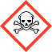 |  |  | Toxic |  |  |  |  | Health Effect |  |  |  |  |  | Irritant/Harmful
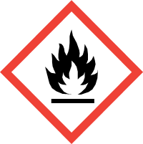 |  |  | Flammable |  |  | 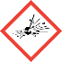 |  | Explosive |  |  | 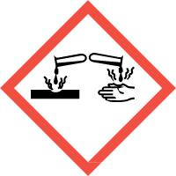 |  |  | Corrosive
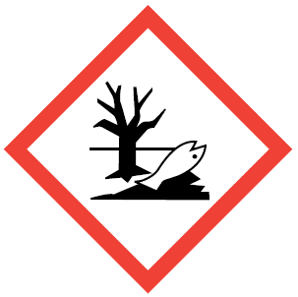 |  |  | Danger to the  environment |  |  | 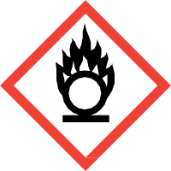 |  | Oxidiser |  |  | 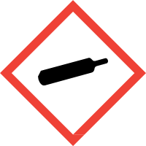 |  |  | Pressurised Gas
 |  |  | Non-hazardous |  |  | Other:
Users: Who should not use this chemical?
 | Expectant and Nursing Mothers |  |  |  | Young Person(s)  (under 18 years) |  |  |  |  | Asthmatic |  |  |  | Sensitised
Other:
Storage: How should this chemical be stored?
 | Locked away for restricted users |  |  |  | Chemical Cupboard |  |  |  |  | Lid Sealed |  |  |  | Ventilated Area
Other:

Controls on Usage: |  |  |  | Usage - type 1 |  |  |  | Usage - type 2
Usage Type:
Description of Process:
Potential Routes of Entry:
Process Controls:
Closed Extraction Booth (LEV)
Open Extraction Booth (LEV)
Well Ventilated Area
(e.g. by window or use of fans)
Non-enclosed Space
(e.g. normal working areas)
Restricted Chemical
(e.g. expertise required)
Enhanced training required
Other Process Control Notes: |  |  |  | Management to monitor use of product
PPE Controls:
 |  | Respiratory Protection:
 |  | Eye Protection:
 | Hand Protection:
 | Skin Protection:
 | Other PPE Control Notes:
Monitoring Controls:
Exposure Monitoring
Other Monitoring Control Notes:
General Usage and Disposal Guidance:
 | Keep from naked flame |  |  | Keep from sources of ignition |  |  | Keep out of direct sunlight |  |  |  | Keep away from heat
 | Store away from drains |  |  | Do not throw in bin |  |  | Wash hands after use
Stability:
Waste Disposal:
Used Wipes etc.
Notes / Comments:

For office use only – Document ref. no.: | v1.

